Modeling hw3

10170437 Mark Taylor

# **Problems**

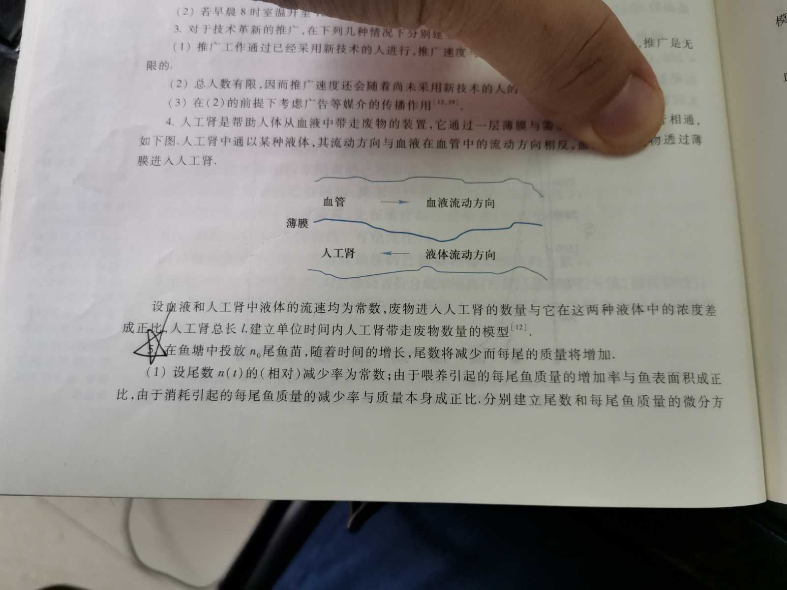

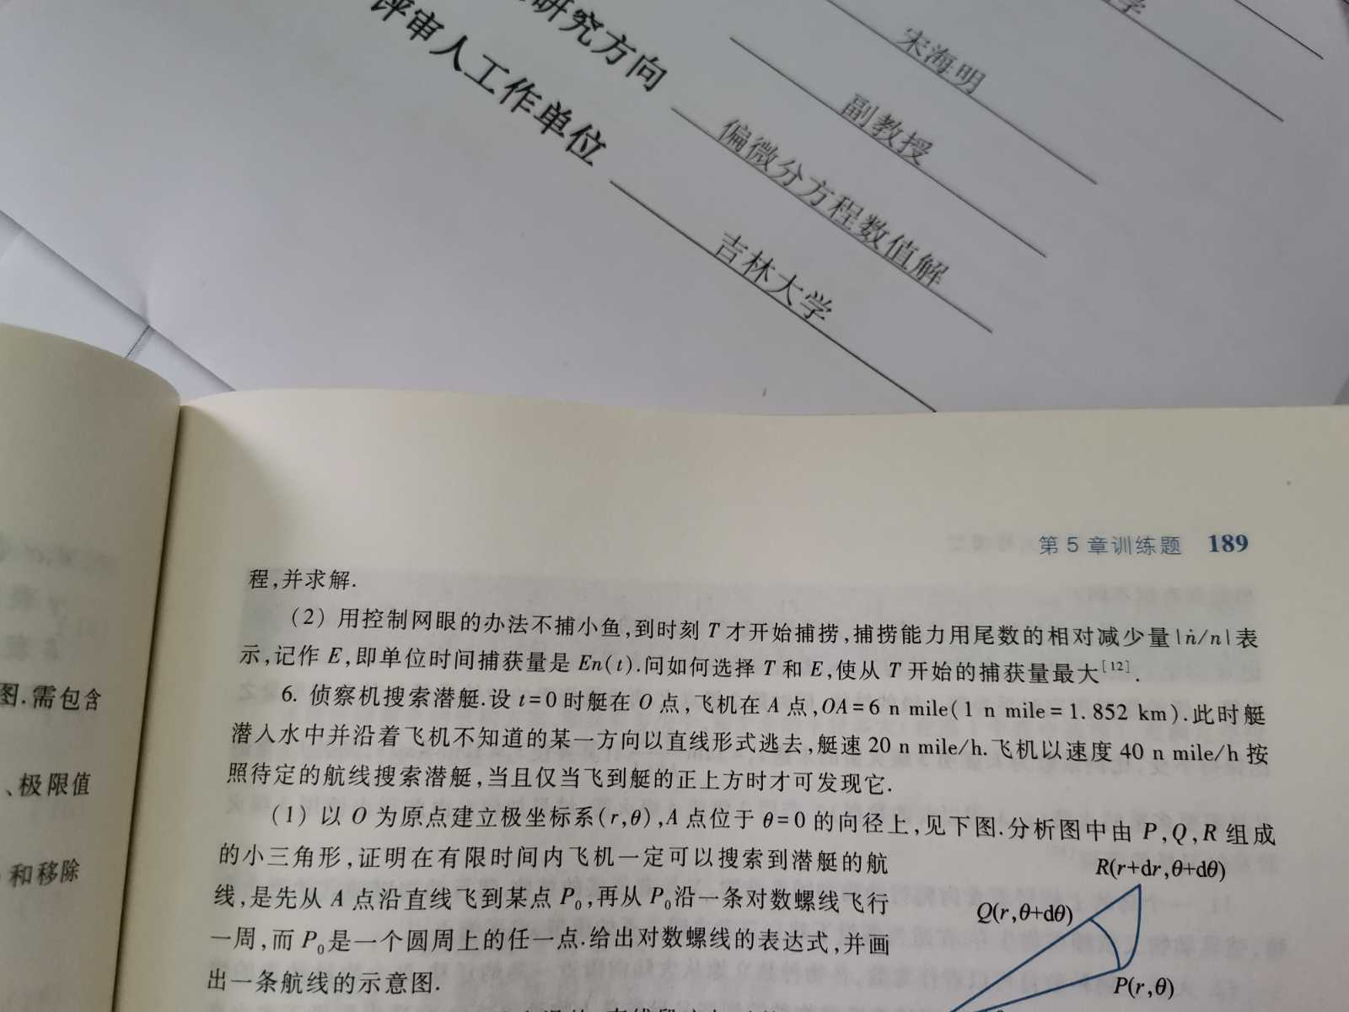

# **Solution**

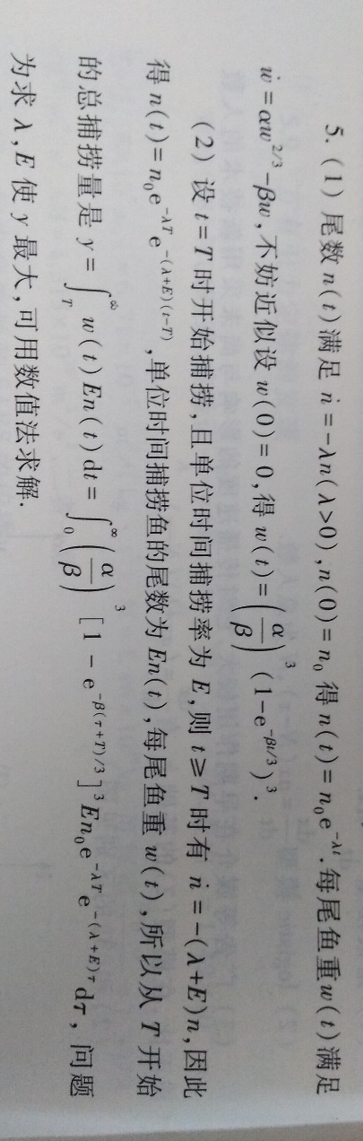

Okay, now let’s try to figure out how to numerically solve this problem.

$$y=\int_{0}^{∞}{{\left(\frac{α}{β}\right)}^{3}{\left[1-e^{-\frac{β\left(τ+T\right)}{3}}\right]}^{3}}En_{0}e^{-λT}e^{-\left(λ+E\right)τ}dτ,$$

Let $τ=\frac{t}{1-t^{2}}$, $0<t<1$, $dτ=\frac{1+t^{2}}{{\left(1-t^{2}\right)}^{2}}dt$, thus

$$y=\int_{0}^{1}{{\left(\frac{α}{β}\right)}^{3}{\left[1-e^{-\frac{β\left(\frac{t}{1-t^{2}}+T\right)}{3}}\right]}^{3}}En_{0}e^{-λT}e^{-\left(λ+E\right)\frac{t}{1-t^{2}}}\frac{1+t^{2}}{{\left(1-t^{2}\right)}^{2}}dt.$$

Then we need to find out the critical point $(λ, E)$ such that $y_{max}$.

## Visualization

See <https://www.geogebra.org/m/uwnwfmze> for the dynamic graph.

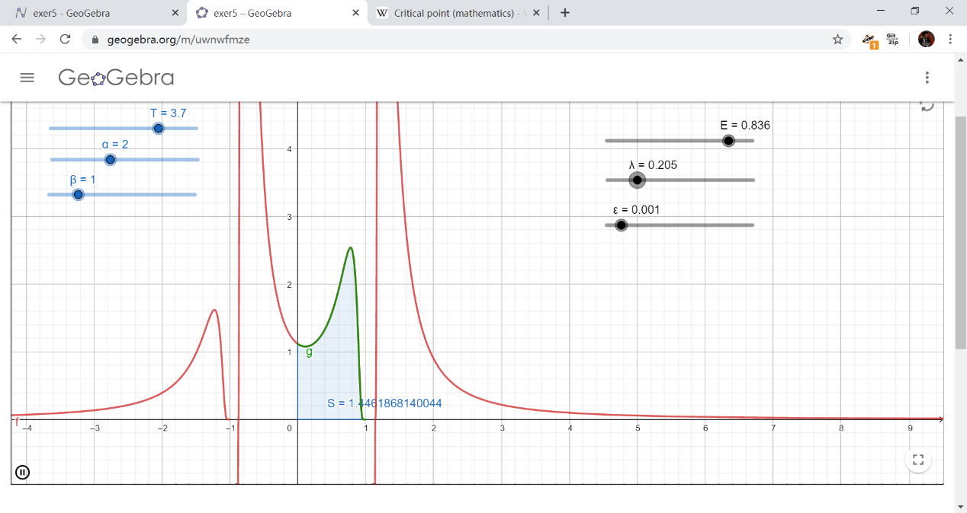

In this graph, $g$ is the goal function to be integrated, i.e.

$$g={\left(\frac{α}{β}\right)}^{3}{\left[1-e^{-\frac{β\left(\frac{t}{1-t^{2}}+T\right)}{3}}\right]}^{3}*E* e^{-λT}e^{-\left(λ+E\right)\frac{t}{1-t^{2}}}\frac{1+t^{2}}{{\left(1-t^{2}\right)}^{2}}, 0≤t<1.$$

Note that we omit the positive constant $n_{0}$, for it has no contribution to the critical point.

The blue sliders are constants as well, you can set those as you like. Since $t=1$ is a discontinuous point, we can only numerically integrate $g$ by interval $[0, 1-ε]$, you can set the $ε$ as well at the right side of the graph.

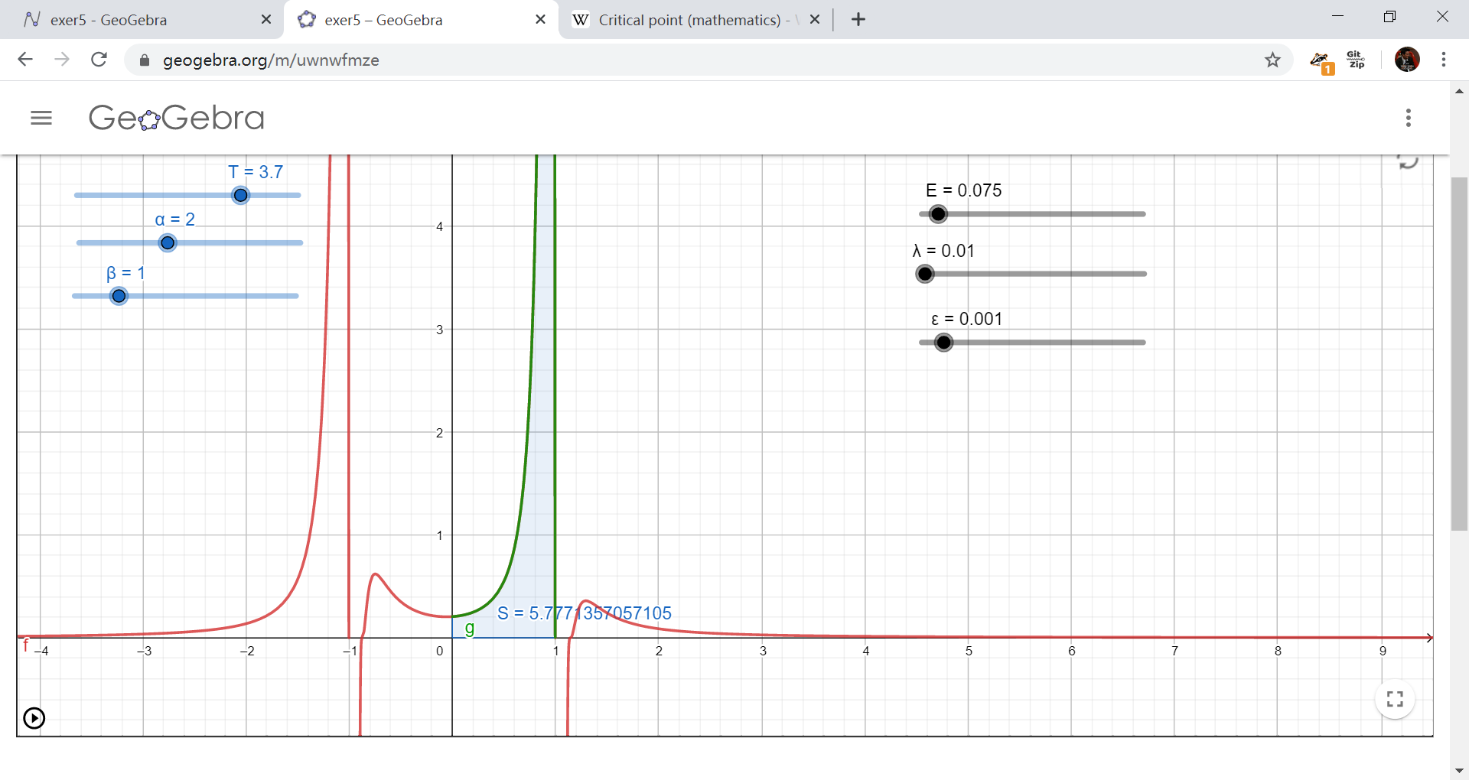Apparently, $g≥0, 0≤x<1$, and $g$ decays as $λ$ increases (you can verify it by dragging slider $λ$ and keeping the rest static). In practical terms, $λ$ is the rate of decrement of fry number that as time goes on (as they grow). The smaller $λ$ is, the more fry will remain. Reasonable.

The critical point might be $\left(λ, E\right)=(0.075, 0.01)$ under the conditions that

$T=3.7, α=2, β=1, ε=0.001$

We can also approximate the critical point by writing a simple MATLAB program, letting $λ$ and $E$ be two vectors, consisting of a series of (evenly spaced) elements, say *linspace(0,1,100)*. Afterwards, get the maximum numerical integral by Simpson’s method or Gaussian quadrature formula, and return this pair of values.